GSCM 521

Abdi Alamir

3/11/2024

**Analysis Assignment 3 - Part B**

**Introduction:**

In our role as operations analysts at the World Bank, we are tasked with evaluating the institution's project portfolio amidst evolving macro-economic conditions. The objective is to determine a method for assessing the needs and risks associated with supporting different countries and regions, all while facing the challenge of reducing project contributions.

This report outlines the initial phase of the analysis, focusing on methodologies, datasets used, and early insights gained. By linking diverse data sources into a unified flat file through an ad hoc ETL process, we have laid the groundwork for a comprehensive analysis, leveraging datasets such as OGHIST, CLASS, and project-specific information.

The business situation necessitates evaluation criteria for both countries and projects, with a focus on defining “need” and “risk.” Preliminary data analysis forms the basis for addressing key business questions, guiding subsequent analysis and insights.

The report progresses into specific findings, supported by relevant visualizations, aiming to illuminate patterns, correlations, and potential areas of concern. The goal is to provide actionable intelligence that aligns with stakeholder objectives, fostering synergy between analytical insights and strategic imperatives.

**Stakeholder's Needs Analysis:**

As operations analysts at the World Bank, understanding the stakeholder's needs is crucial to effectively addressing the challenges of decreasing the number of projects the World Bank can support due to current macroeconomic conditions. The stakeholder, in this case, likely comprises senior management, project managers, and other decision-makers involved in project selection and resource allocation. Here's a detailed analysis of the stakeholder's needs:

**1. Project Prioritization:**

- The stakeholder needs a systematic method for prioritizing projects to ensure optimal allocation of resources.

- They require insights into the criteria used for project selection and the rationale behind prioritizing certain projects over others.

**2. Resource Optimization:**

- Given the constraints on resources, the stakeholder needs strategies to maximize the impact of available funds.

- They need recommendations on how to allocate resources efficiently, considering the potential benefits and risks associated with each project.

**3. Risk Management:**

- Managing project risks is a critical concern for the stakeholder, especially in the context of uncertain economic conditions.

- They require tools and frameworks for assessing and mitigating risks associated with project implementation, including financial, political, and operational risks.

**4. Impact Assessment:**

- The stakeholder seeks insights into the expected impact of projects on the target countries/regions.

- They need methods for evaluating the socio-economic outcomes of projects and measuring progress towards development goals.

**5. Financial Sustainability:**

- Ensuring the financial sustainability of projects and their long-term viability is a key priority for the stakeholder.

- They need strategies for identifying and supporting projects that are financially feasible and can attract additional financing beyond the World Bank's contribution.

**6. Alignment with Development Goals:**

- The stakeholder aims to align project investments with the development priorities of recipient countries/regions.

- They require evidence-based recommendations on how to tailor project interventions to address specific development challenges effectively.

**7. Transparency and Accountability:**

- The stakeholder emphasizes the importance of transparency and accountability in project selection and implementation.

- They seek clear documentation of decision-making processes and mechanisms for monitoring and evaluating project performance.

**8. Data-Driven Decision Making:**

- Leveraging data and analytics is essential for informed decision-making.

- The stakeholder needs access to reliable data sources and analytical tools to support evidence-based decision-making across all stages of the project lifecycle.

**9. Capacity Building:**

- Building institutional capacity within the World Bank and partner organizations is critical for delivering successful projects.

- The stakeholder seeks opportunities for knowledge sharing, training, and collaboration to strengthen project management capabilities.

**10. Adaptability to Changing Conditions:**

- Given the dynamic nature of global economic trends and geopolitical factors, the stakeholder emphasizes the need for flexibility and adaptability in project planning and implementation.

- They require strategies for anticipating and responding to emerging challenges and opportunities.

Addressing these needs requires a comprehensive approach that integrates data analysis, risk assessment, stakeholder engagement, and strategic decision-making. By aligning project priorities with development objectives and maximizing the impact of available resources, the World Bank can effectively navigate the current macroeconomic conditions and continue to support sustainable development initiatives worldwide.

**ETL: Linkage Strategy:**

**1. Data Evaluation and Selection:**

Each dataset from the World Bank underwent a thorough evaluation to identify sheets or tabs containing pertinent information aligned with the analysis requirements. The selection process aimed to pinpoint key data sources that directly addressed the business questions posed in the analysis assignment.

Specifically, the following tabs were selected from each dataset:

1.. World Bank - CLASS:

- Groups

- List of economies (critical for mapping countries/regions/codes)

- Merge Groups with List of economies on “CountryCode” and “Code”

2. World Bank - OGHIST:

- Country Analytical History

- Country Indebtedness History

- Merge both to World Bank - CLASS file on “Code” and “CountryCode”

3. World Bank - all:

- World Bank Projects

- Merge with List of economies tab from World Bank - CLASS file by regionname and countryname Economy and Region. Manually adjust for missing incorrect matching records.

Additionally, the file “World Bank – WDIExcel” was subjected to a parallel assessment, treating it as a standalone file. Tabs relevant to economic indicators, country classifications, and project details were identified and included in the subsequent ETL process. This comprehensive approach ensured that all potential sources of relevant data were considered for the analysis, aligning with the overarching objectives of the assignment.

**2. Cleaning and Preprocessing:**

- Rigorous cleaning procedures were applied to ensure data integrity and consistency.

- Initial steps involved the removal of extraneous rows and columns that did not contribute to the analysis.

- Rows containing notes, headers, or introductory comments were eliminated to maintain dataset uniformity and clarity.

- Missing or erroneous values were addressed through techniques like imputation or removal, depending on the significance of the data field.

**3. Joining and Integration with Main Dataset:**

- The integration process involved establishing logical connections between datasets using common identifiers.

- Country names, project IDs, or unique codes served as key linking variables to merge disparate datasets.

- Special attention was given to ensure data alignment and consistency across files, resolving discrepancies in naming conventions or coding systems.

- Advanced merging techniques, such as inner, outer, left, or right joins, were employed based on the desired outcome and analysis requirements.

**4. Alignment with Analysis Objectives:**

- At each stage, data selection and integration decisions were guided by the overarching analysis objectives.

- Business questions and stakeholder needs provided a framework for prioritizing relevant variables and dimensions.

- Data integration strategies were tailored to extract maximum insights while minimizing noise and redundancy in the final dataset.

**5. Column Naming and Enhancement:**

- Column names underwent a review process to ensure clarity, consistency, and relevance to the analysis.

- Descriptive labels were added or refined to convey the meaning and context of each data attribute effectively.

- Ambiguous or generic column names were replaced with specific, informative labels to enhance the interpretability of the dataset.

By adhering to a systematic and detail-oriented approach, the ETL process ensured that the final analysis dataset embodies the richness and complexity of the underlying data sources, empowering stakeholders to make informed decisions and derive actionable insights.

**6. Exploratory Data Analysis:**

- The merge dataset contains 85 features (5 floats, 80 objects) and 2,563 records

- Total missing values is 1,248 with the highest coming from the “Lending category” (37.6%). The missing values were dropped in the analysis.

-

- We then looked at the lending categories within each income group. Showing the Lower middle income being the highest for IDA, Upper middle income for IBRD, and Upper middle income for the Blend category (Figure 1).

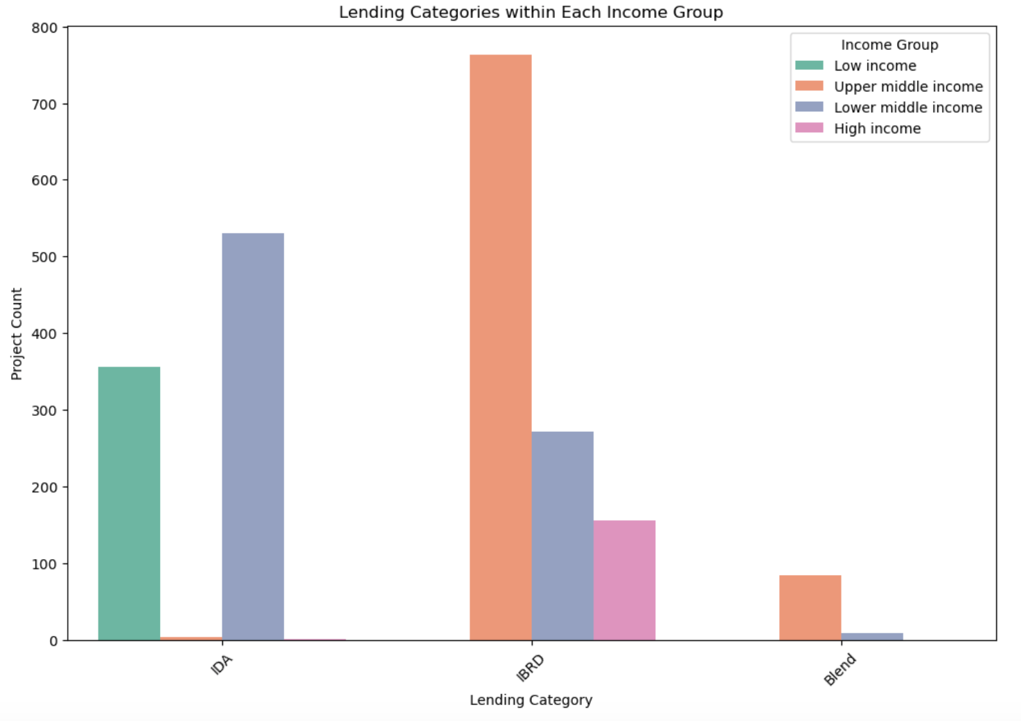

**Figure 1.** Lending Categories within Each Income Group

- We also looked at the total project count by income group and lending category (Figure 2).

- The highest number of projects (530) for IDA category is in Lower middle income (65.4%).

- The highest number of projects (763) for IBRD category is in Upper middle income (75.1%).

- The highest number of projects (84) for the Blend category is in Upper middle income category (8.3%).

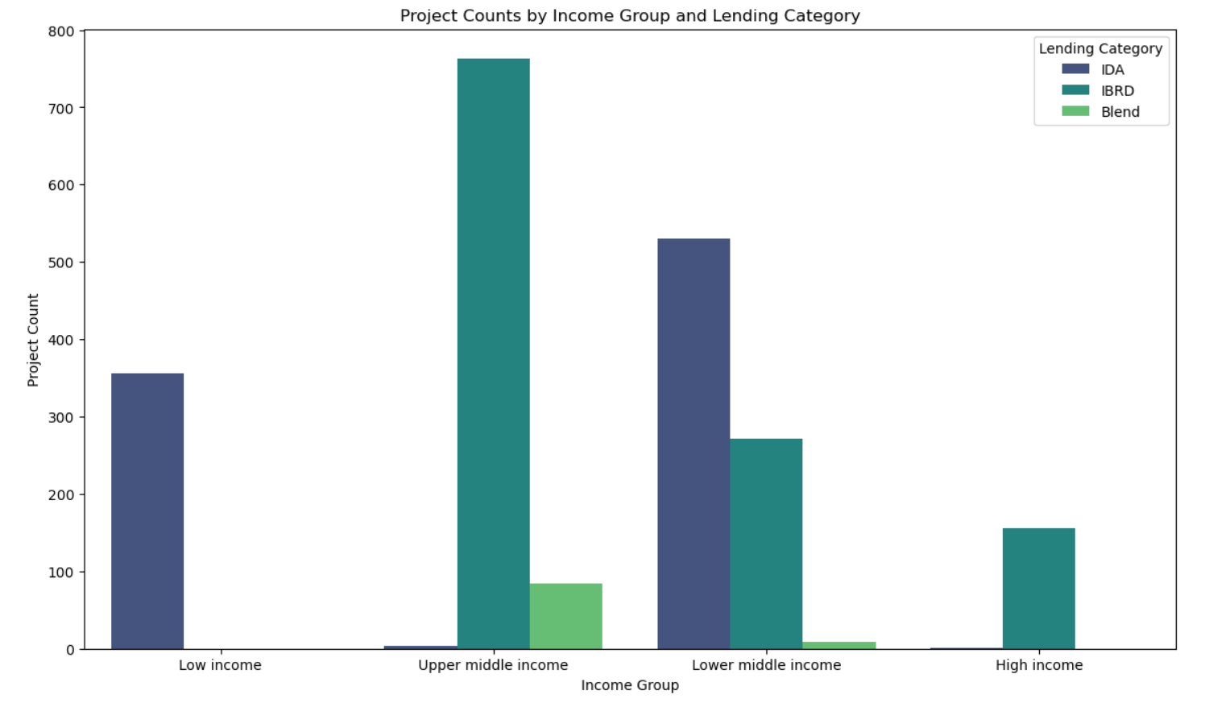

**Figure 2.** Project Counts by Income Group and Lending Category

**Proposed Questions:**

**1. Economic Indicators and Trends:**

The analysis of indebtedness levels across various regions reveals intriguing patterns that offer insights into regional financial dynamics (Figure 3). Notably, Europe & Central Asia predominantly feature regions classified as Less Indebted (LIN), suggesting stable financial landscapes buoyed by robust economic policies. Conversely, South Asia shows a similar trend but also includes regions classified as Not Classified by Indebtedness (NIN), signifying potential challenges in financial assessment accuracy.

Surprisingly, Moderately Indebted (MIN) regions are absent in East Asia, raising questions about the financial environment in this region. Furthermore, the absence of Less Indebted (LIN) regions in East Asia highlights the need for deeper exploration into financial dynamics. To address these findings, recommendations include enhancing financial monitoring mechanisms, conducting regional assessments, fostering knowledge-sharing platforms, and investing in capacity-building programs to strengthen financial resilience and decision-making capabilities.

**Figure 3.** Histogram of Indebtedness in 2005 by Region

The analysis of indebtedness trends by income groups over time unveils compelling insights into financial dynamics across various economic strata. A line chart representing indebtedness levels by income group indicates that the upper middle-income category consistently exhibits the highest indebtedness levels across the years under review (Figure 4). Particularly noteworthy is the significant spike in indebtedness observed in the year 1992, highlighting potential economic challenges or financial events that occurred during that period. Moreover, the data suggests that regions classified as Middle Income (MN) consistently demonstrate higher levels of indebtedness compared to other income groups.

To address these trends effectively, stakeholders could consider implementing targeted financial interventions, such as debt restructuring programs, financial education initiatives, and policy reforms aimed at mitigating excessive indebtedness and fostering sustainable economic growth across income groups. Additionally, fostering cross-regional collaboration and knowledge-sharing platforms could facilitate the exchange of best practices and strategies for managing indebtedness effectively in diverse economic contexts.

**Figure 4.** Indebtedness Trends by Income Group

**2. Project Classification and Selection Criteria:**

The barplot visualization reveals lending category distribution across income groups (Figure 5). IBRD tops lending, followed by IDA, while Blend has the least frequency. To optimize resource allocation, stakeholders should refine lending strategies, explore innovative financing, and foster transparent communication to maximize development impact across income groups.

**Figure 5.** Count of Projects by Lending Category

The heatmap reveals key patterns in country distribution by income group and lending category (Figure 6). Darker shades signify higher frequencies, with the IBRD lending category being most prevalent among upper middle-income countries. Meanwhile, lower upper-income nations show significant reliance on the IDA lending category.

These insights can guide tailored financing strategies, fostering partnerships with institutions like the IBRD and IDA to address diverse country needs. Policymakers can prioritize funding and design interventions to promote inclusive development, aligning financing mechanisms with each country's unique context and priorities.

**Figure 6.** Distribution of Countries by Income Group and Lending Category

**3. Project Performance and Completion Rates**:

The countplot reveals that the majority of projects are marked as closed, with other status categories like active, archived, and pipeline having lower representation (Figure 7). This suggests a trend towards project completion, emphasizing the need for ongoing monitoring and evaluation practices. Understanding the distribution of project statuses can inform resource allocation and strategic decision-making processes within the organization.

**Figure 7.** Count of Projects by Project Status

Figure 8 below displays the top ten countries/regions with the highest project completion rates: Nepal, Burkina Faso, and West Bank and Gaza lead the list, followed by Korea Republic, Ukraine, Romania, Russian Federation, Bosnia, Djibouti, and Jamaica. This ranking offers insights into project completion dynamics, aiding in identifying effective management practices and areas for improvement.

**Figure 8.** Top 10 Completion Rates by Country/Region

Figure 9 below shows the top 10 sectors based on the number of projects. The leading sectors include: central government, social protection, health, and public administration, among others. This breakdown offers insights into the focus areas of World Bank projects, highlighting priority sectors for investment and development initiatives.

**Figure 10.** Top 10 Sectors

The visualization presents the top 10 themes based on the number of projects (Figure 11). Key themes such as public expenditure and financial management, infrastructure services for private sector development, and debt management emerge as significant areas of focus for World Bank projects. This breakdown sheds light on the thematic priorities driving project investments and underscores the diverse spectrum of development initiatives undertaken by the World Bank.

**Figure 11.** Top 10 Themes

**4. Country Indebtedness and Financing Needs:**

Figure 12 illustrates the average total commitments categorized by indebtedness in 2005. Notably, countries with low indebtedness (LN) demonstrate the highest average total commitments, followed by moderately indebted (MIN) countries, severely indebted (SIN) nations, and those not classified by indebtedness (NIN). This insight suggests varying financial dynamics across different indebtedness categories and underscores the importance of understanding financial contexts when allocating resources for World Bank projects.

**Figure 12.** Average Total Commitments by Indebtedness Category (2005)

Figure 13 displays average total commitments across indebtedness categories in 2005. Notably, both “Less Indebted (LIN)” and “Moderately Indebted (MIN)” categories show the highest commitments, followed by "Severely Indebted (SIN)" with approximately half the commitments. “Not Classified by Indebtedness (NIN)” records roughly half of those in SIN. These findings underline distinct financing needs across different indebtedness levels.

**Figure 13.** Count of Countries/Regions by Indebtedness Category (2005)

**5. Sectoral and Thematic Alignment:**

Figure 14 illustrates the top 10 sectors/themes based on total commitments. “Central Government (Central Agencies)” emerges as the sector with the highest commitments, followed by “Banking Institutions” and “Social Protection.” Notably, sectors such as “Health” and “Other Public Administration” also receive substantial commitments.

**Figure 14.** Top 10 Total Commitments by Sector

Figure 15 showcases the top 10 themes by total commitments. “Public expenditure, financial management and planning” leads the list, followed by “Infrastructure services for private sector development” and “Other financial and private sector development.” The remaining themes include “Debt management and fiscal sustainability,” “Macroeconomic management,” “Rural services and infrastructure,” “Health system performance,” “Social Safety Nets/Social Assistance & Social,” “Tax policy and administration,” and “Trade facilitation and market access.” These themes represent key investment areas with significant financial commitments.

**Figure 15.** Top 10 Total Commitments by Theme

Figure 16 illustrates the top 10 sectors and themes based on total commitments. “Central Government (Central Agencies)” emerges as the sector/theme with the highest commitment, followed by “Banking Institutions” and “Social Protection.” Other notable sectors/themes include “Other Industry, Trade and Services,” “Health,” and “Other Public Administration.” These findings shed light on the significant investment distribution across different sectors and themes, highlighting areas of focus for World Bank projects.

**Figure 16.** Top 10 Total Commitments by Sector/Theme

**General Recommendations:**

1. Diversification of Investments: Given the concentration of commitments in certain sectors/themes, it is advisable to diversify investments across a broader spectrum of sectors. This diversification strategy can mitigate risks associated with over-reliance on specific sectors/themes and foster balanced economic development.

2. Strategic Allocation: Prioritize sectors/themes that demonstrate substantial impact potential and align closely with the development goals of recipient countries/regions. This strategic allocation ensures that investments effectively address the most pressing socio-economic challenges and contribute to sustainable growth and poverty reduction.

3. Enhanced Monitoring and Evaluation: Implement robust monitoring and evaluation frameworks to assess the effectiveness and efficiency of projects across various sectors/themes. Regular assessments enable stakeholders to identify areas of improvement, optimize resource allocation, and ensure that projects achieve intended outcomes.

4. Stakeholder Collaboration: Foster collaboration and partnerships with relevant stakeholders, including governments, international organizations, and local communities. Engaging stakeholders throughout the project lifecycle enhances transparency, promotes ownership, and increases the likelihood of project success.

**Conclusion:**

The analysis of project performance and investment trends provides valuable insights for optimizing the allocation of resources and enhancing the impact of World Bank projects. By leveraging data-driven approaches and strategic decision-making, the World Bank can address complex development challenges more effectively and contribute to positive socio-economic transformations worldwide. Moving forward, continued emphasis on diversification, strategic allocation, and stakeholder engagement will be important in achieving sustainable development goals and fostering inclusive prosperity across diverse regions and sectors.